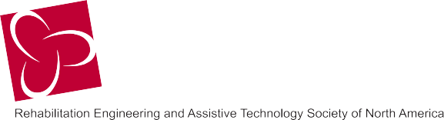

Wednesday, June 28, 2017 – 6:30 to 9:00 PM, CDT
New Orleans Riverboat Dinner Cruise – Founders Fund Benefit
Join friends and colleagues for a fun night on the mighty Mississippi River to benefit the RESNA Founders Fund! Enjoy local cuisine, live music, and incredible views of New Orleans aboard the Creole Queen, a vintage Mississippi Riverboat - all for a good cause.

Personal Information

First Name ______________________________________ Last Name __________________________________________

E-mail ____________________________________________________ Phone ___________________________________

Street Address ___________________________________________________________________ Suite/Apt __________

City________________________ State/Province _______________ Postal Code __________ Country _______________

Payment Information

Ticket Amount: ☐ $100

Additional Donation Amount: ☐ $50 ☐ $100 ☐$165 ☐$250 ☐$500 ☐Other $_______________

Total Amount: _________________

VISA/Master Card Number__________________________________ Expiration Date _______ Security Code/CVV _______

Name on Card ________________________________________________________________________________________

Billing Address (if different from above) ___________________________________________________________________

If paying by credit card, please scan and email this form to jwilliams@resna.org or fax it to (703) 524-6630.

If paying by check, please enclose and make payable to “RESNA Founders Fund.”

Mail check with form to:
RESNA
1560 Wilson Blvd, Suite 850
Arlington, VA 22209
ATTN: Founders Fund

Thank You!

Promoting technology solutions for people with disabilities

resna.org

1560 Wilson Blvd • Suite 850• Arlington, VA 22209-1903 • t: 703-524-6686 f: 703-524-6630

