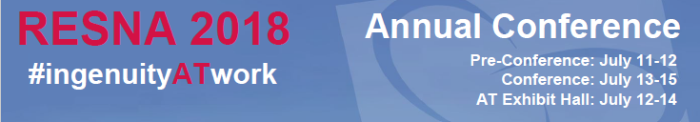

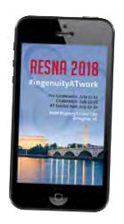

RESNA App Promotion Specifications
Sponsors receive one (1) occurrence of the following App opportunities based on the following sponsorship levels:
- Platinum: All six (6) opportunities
- Gold: Any four (4) opportunities
- Silver: Any three (3) opportunities
- Bronze: Any two (2) opportunities
For opportunities beyond an initial app opportunity, please see pages 5 – 10.
Each sponsor needs to provide a 180x120 px JPG or PNG company logo for the app. This will be present under our list of sponsors, exhibitors, and advertisers.
Below is the layout for the sponsorship of each promotional opportunity.
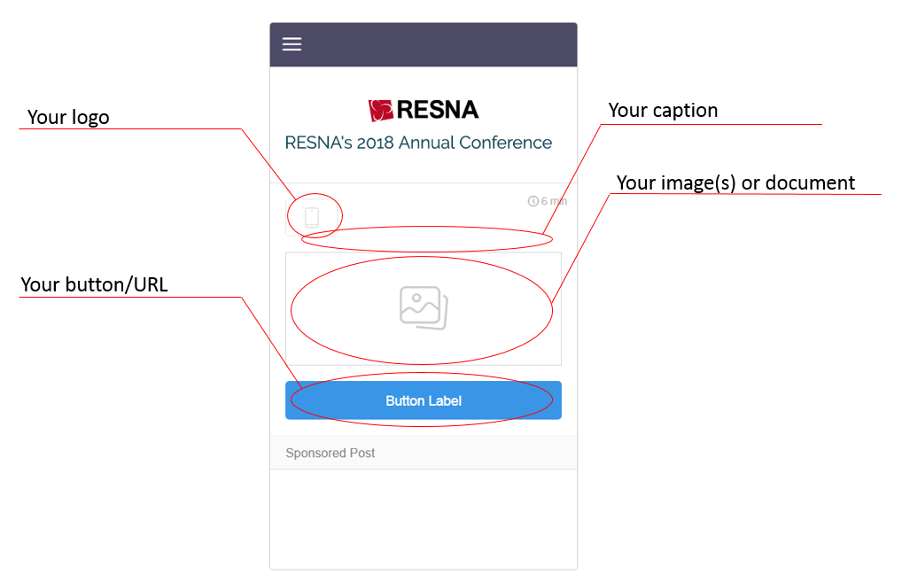

Please select the initial app advertising opportunity on the next page and provide the requested information.

Initial App Advertising Opportunity

☐ eCommerce
($2.000 if not included in package): Offer attendees a discount code or access to your online store to take action on the offer right away.
- Organization Name: Click or tap here to enter text.
- Number of Opportunities: Click here to enter text.
- Choose a date: Choose an item.
- Choose a time between: Choose an item. and Choose an item.
- Caption (140 characters): Click or tap here to enter text.
- Image Label: Click or tap here to enter text.
- Image (minimum 580x256 px)
- Target URL: Click or tap here to enter text.

☐ Gallery
($1,250 if not included in package): Introduce a new product or share a visual experience with attendees in a photo gallery on the timeline.
- Organization Name: Click or tap here to enter text.
- Number of Opportunities: Click here to enter text.
- Choose a date: Choose an item.
- Choose a time between: Choose an item. and Choose an item.
- Caption (140 characters): Click or tap here to enter text.
- Image Label: Click or tap here to enter text.
- Images (minimum 476x476 px – up to 10 images)
- Target URL: Click or tap here to enter text.

☐ Social Ad
($750 if not included in package): A 5-second post on the home screen, with an action button to any destination.
- Organization Name: Click or tap here to enter text.
- Number of Opportunities: Click here to enter text.
- Choose a date: Choose an item.
- Choose a time between: Choose an item. and Choose an item.
- Caption (140 characters): Click or tap here to enter text.
- Image Label: Click or tap here to enter text.
- Image (minimum 580x256 px)
- Target URL: Click or tap here to enter text.

☐ Sponsored Session
($500 if not included in package): Introduce your sponsors’ speaking slot(s) at the event or want to promote one of your sessions on the timeline.
- Organization Name: Click or tap here to enter text.
- Number of Opportunities: Click here to enter text.
- Choose a date: Choose an item.
- Choose a time between: Choose an item. and Choose an item.
- Promoted Session
  - Instructional course: Choose an item.
  - Workshop/Symposia: Choose an item.
  - Paper Platform: Choose an item.
- Caption (140 characters): Click or tap here to enter text.
- Image Label: Click or tap here to enter text.
- Image (minimum 580x256 px)
- Target URL: Click or tap here to enter text.

☐ App Download
($300 if not included in package): Direct attendees to your mobile app in the App Store or Google Play to download it directly.
- Organization Name: Click or tap here to enter text.
- Number of Opportunities: Click here to enter text.
- Choose a date: Choose an item.
- Choose a time between: Choose an item. and Choose an item.
- Caption (140 characters): Click or tap here to enter text.
- Image Label: Click or tap here to enter text.
- Image specifications (minimum 580 x 256 px)
- App store URL: Click or tap here to enter text.
- Google Play URL: Click or tap here to enter text.

☐ Helpful Tip
($200 if not included in package): Feature a splash screen while the app loads. Great real estate to have your logo featured.
- Organization Name: Click or tap here to enter text.
- Number of Opportunities: Click here to enter text.
- Caption (140 characters): Click or tap here to enter text.
- Choose a date: Choose an item.
- Choose a time between: Choose an item. and Choose an item.
- Image Label: Click or tap here to enter text.
- Image specifications (minimum 580 x 256 px)
- Document specifications (.pdf, .doc, .docx, or .ppt)

Additional eCommerce
Please complete the specifications for each additional App opportunity
(check all that apply)
Offer attendees a discount code or access to your online store to take action on the offer right away.

☐ 2nd $1,750
☐ 3rd $1,500
☐ 4th $1,250
☐ 5th $1,000
☐ 6th $750
☐ 7th + $500

- Choose a date: Choose an item. and a time between: Choose an item. and Choose an item.
- Caption (140 characters): Click or tap here to enter text.
- Image Label: Click or tap here to enter text.
- Image (minimum 580x256 px)
- Target URL: Click or tap here to enter text.
- Choose a date: Choose an item. and a time between: Choose an item. and Choose an item.
- Caption (140 characters): Click or tap here to enter text.
- Image Label: Click or tap here to enter text.
- Image (minimum 580x256 px)
- Target URL: Click or tap here to enter text.
- Choose a date: Choose an item. and a time between: Choose an item. and Choose an item.
- Caption (140 characters): Click or tap here to enter text.
- Image Label: Click or tap here to enter text.
- Image (minimum 580x256 px)
- Target URL: Click or tap here to enter text.
- Choose a date: Choose an item. and a time between: Choose an item. and Choose an item.
- Caption (140 characters): Click or tap here to enter text.
- Image Label: Click or tap here to enter text.
- Image (minimum 580x256 px)
- Target URL: Click or tap here to enter text.
- Choose a date: Choose an item. and a time between: Choose an item. and Choose an item.
- Caption (140 characters): Click or tap here to enter text.
- Image Label: Click or tap here to enter text.
- Image (minimum 580x256 px)
- Target URL: Click or tap here to enter text.
- Choose a date: Choose an item. and a time between: Choose an item. and Choose an item.
- Caption (140 characters): Click or tap here to enter text.
- Image Label: Click or tap here to enter text.
- Image (minimum 580x256 px)
- Target URL: Click or tap here to enter text.

Additional Gallery
Please complete the specifications for each additional App opportunity
(check all that apply)
Introduce a new product or share a visual experience with attendees in a photo gallery on the timeline.

☐ 2nd $1,000
☐ 3rd $750
☐ 4th $500
☐ 5th + $250

- Choose a date: Choose an item. and a time between: Choose an item. and Choose an item.
- Caption (140 characters): Click or tap here to enter text.
- Image Label: Click or tap here to enter text.
- Images (minimum 476x476 px – up to 10 images)
- Target URL: Click or tap here to enter text.
- Choose a date: Choose an item. and a time between: Choose an item. and Choose an item.
- Caption (140 characters): Click or tap here to enter text.
- Image Label: Click or tap here to enter text.
- Images (minimum 476x476 px – up to 10 images)
- Target URL: Click or tap here to enter text.
- Choose a date: Choose an item. and a time between: Choose an item. and Choose an item.
- Caption (140 characters): Click or tap here to enter text.
- Image Label: Click or tap here to enter text.
- Images (minimum 476x476 px – up to 10 images)
- Target URL: Click or tap here to enter text.
- Choose a date: Choose an item. and a time between: Choose an item. and Choose an item.
- Caption (140 characters): Click or tap here to enter text.
- Image Label: Click or tap here to enter text.
- Images (minimum 476x476 px – up to 10 images)
- Target URL: Click or tap here to enter text.
- Choose a date: Choose an item. and a time between: Choose an item. and Choose an item.
- Caption (140 characters): Click or tap here to enter text.
- Image Label: Click or tap here to enter text.
- Images (minimum 476x476 px – up to 10 images)
- Target URL: Click or tap here to enter text.
- Choose a date: Choose an item. and a time between: Choose an item. and Choose an item.
- Caption (140 characters): Click or tap here to enter text.
- Image Label: Click or tap here to enter text.
- Images (minimum 476x476 px – up to 10 images)
- Target URL: Click or tap here to enter text.

Additional Social Ad
Please complete the specifications for each additional App opportunity
(check all that apply)
A 5-second post on the home screen, with an action button to any destination.

☐ 2nd $1,000
☐ 3rd $750
☐ 4th $500
☐ 5th + $250

- Choose a date: Choose an item. and a time between: Choose an item. and Choose an item.
- Caption (140 characters): Click or tap here to enter text.
- Image Label: Click or tap here to enter text.
- Image (minimum 580x256 px)
- Target URL: Click or tap here to enter text.
- Choose a date: Choose an item. and a time between: Choose an item. and Choose an item.
- Caption (140 characters): Click or tap here to enter text.
- Image Label: Click or tap here to enter text.
- Image (minimum 580x256 px)
- Target URL: Click or tap here to enter text.
- Choose a date: Choose an item. and a time between: Choose an item. and Choose an item.
- Caption (140 characters): Click or tap here to enter text.
- Image Label: Click or tap here to enter text.
- Image (minimum 580x256 px)
- Target URL: Click or tap here to enter text.
- Choose a date: Choose an item. and a time between: Choose an item. and Choose an item.
- Caption (140 characters): Click or tap here to enter text.
- Image Label: Click or tap here to enter text.
- Image (minimum 580x256 px)
- Target URL: Click or tap here to enter text.
- Choose a date: Choose an item. and a time between: Choose an item. and Choose an item.
- Caption (140 characters): Click or tap here to enter text.
- Image Label: Click or tap here to enter text.
- Image (minimum 580x256 px)
- Target URL: Click or tap here to enter text.
- Choose a date: Choose an item. and a time between: Choose an item. and Choose an item.
- Caption (140 characters): Click or tap here to enter text.
- Image Label: Click or tap here to enter text.
- Image (minimum 580x256 px)
- Target URL: Click or tap here to enter text.

Additional Sponsored Session
Please complete the specifications for each additional App opportunity
(check all that apply)
Introduce your sponsors’ speaking slot(s) at the event or want to promote one of your sessions on the timeline.

☐ 2nd $250
☐ 3rd $100
☐ 4th + $50

- Choose a date: Choose an item. and a time between: Choose an item. and Choose an item.
- Promoted Session
  - Instructional course: Choose an item.
  - Workshop/Symposia: Choose an item.
  - Paper Platform: Choose an item.
- Caption (140 characters): Click or tap here to enter text.
- Image Label: Click or tap here to enter text.
- Image (minimum 580x256 px)
- Target URL: Click or tap here to enter text.

- Choose a date: Choose an item. and a time between: Choose an item. and Choose an item.
- Promoted Session
  - Instructional course: Choose an item.
  - Workshop/Symposia: Choose an item.
  - Paper Platform: Choose an item.
- Caption (140 characters): Click or tap here to enter text.
- Image Label: Click or tap here to enter text.
- Image (minimum 580x256 px)
- Target URL: Click or tap here to enter text.

- Choose a date: Choose an item. and a time between: Choose an item. and Choose an item.
- Promoted Session
  - Instructional course: Choose an item.
  - Workshop/Symposia: Choose an item.
  - Paper Platform: Choose an item.
- Caption (140 characters): Click or tap here to enter text.
- Image Label: Click or tap here to enter text.
- Image (minimum 580x256 px)
- Target URL: Click or tap here to enter text.

Additional App Download
Please complete the specifications for each additional App opportunity
(check all that apply)
Direct attendees to your mobile app in the App Store or Google Play to download it directly.
☐ 2nd $200
☐ 3rd $100
☐ 4th + $50
- Choose a date: Choose an item. and a time between: Choose an item. and Choose an item.
- Caption (140 characters): Click or tap here to enter text.
- Image Label: Click or tap here to enter text.
- Image specifications (minimum 580 x 256 px)
- App store URL: Click or tap here to enter text.
- Google Play URL: Click or tap here to enter text.
- Choose a date: Choose an item. and a time between: Choose an item. and Choose an item.
- Caption (140 characters): Click or tap here to enter text.
- Image Label: Click or tap here to enter text.
- Image specifications (minimum 580 x 256 px)
- App store URL: Click or tap here to enter text.
- Google Play URL: Click or tap here to enter text.
- Choose a date: Choose an item. and a time between: Choose an item. and Choose an item.
- Caption (140 characters): Click or tap here to enter text.
- Image Label: Click or tap here to enter text.
- Image specifications (minimum 580 x 256 px)
- App store URL: Click or tap here to enter text.
- Google Play URL: Click or tap here to enter text.
- Choose a date: Choose an item. and a time between: Choose an item. and Choose an item.
- Caption (140 characters): Click or tap here to enter text.
- Image Label: Click or tap here to enter text.
- Image specifications (minimum 580 x 256 px)
- App store URL: Click or tap here to enter text.
- Google Play URL: Click or tap here to enter text.
- Choose a date: Choose an item. and a time between: Choose an item. and Choose an item.
- Caption (140 characters): Click or tap here to enter text.
- Image Label: Click or tap here to enter text.
- Image specifications (minimum 580 x 256 px)
- App store URL: Click or tap here to enter text.
- Google Play URL: Click or tap here to enter text.

Additional Helpful Tip
Please complete the specifications for each additional App opportunity
(check all that apply)
Feature a splash screen while the app loads. Great real estate to have your logo featured.
☐ 2nd $150
☐ 3rd $100
☐ 4th + $50
- Choose a date: Choose an item. and a time between: Choose an item. and Choose an item.
- Caption (140 characters): Click or tap here to enter text.
- Image Label: Click or tap here to enter text.
- Image specifications (minimum 580 x 256 px)
- Document specifications (.pdf, .doc, .docx, or .ppt)
- Choose a date: Choose an item. and a time between: Choose an item. and Choose an item.
- Caption (140 characters): Click or tap here to enter text.
- Image Label: Click or tap here to enter text.
- Image specifications (minimum 580 x 256 px)
- Document specifications (.pdf, .doc, .docx, or .ppt)
- Choose a date: Choose an item. and a time between: Choose an item. and Choose an item.
- Caption (140 characters): Click or tap here to enter text.
- Image Label: Click or tap here to enter text.
- Image specifications (minimum 580 x 256 px)
- Document specifications (.pdf, .doc, .docx, or .ppt)
- Choose a date: Choose an item. and a time between: Choose an item. and Choose an item.
- Caption (140 characters): Click or tap here to enter text.
- Image Label: Click or tap here to enter text.
- Image specifications (minimum 580 x 256 px)
- Document specifications (.pdf, .doc, .docx, or .ppt)
- Choose a date: Choose an item. and a time between: Choose an item. and Choose an item.
- Caption (140 characters): Click or tap here to enter text.
- Image Label: Click or tap here to enter text.
- Image specifications (minimum 580 x 256 px)
- Document specifications (.pdf, .doc, .docx, or .ppt)

Calculate Your Total

Initial App Purchases
Opportunity Price (if not included) Select Sub-total
eCommerce $2,000 ☐ ____________________
Gallery $1,250 ☐ ____________________
Social Ad $750 ☐ ____________________
Sponsored Session $500 ☐ ____________________
App Download $300 ☐ ____________________
Helpful Tip $200 ☐ ____________________
Total ____________________

Additional App Purchase
Opportunity | 2nd | 3rd | 4th | 5th | 6th | 7th | Subtotal
eCommerce | ☐ $1,750 | ☐ $1,500 | ☐ $1,250 | ☐ $1,000 | ☐ $750 | ☐ $500* | ____________________
Gallery | ☐ $1,000 | ☐ $750 | ☐ $500 | ☐ $250* |  |  | ____________________
Social Ad | ☐ $1,000 | ☐ $750 | ☐ $500 | ☐ $250* |  |  | ____________________
Sponsored Session | ☐ $250 | ☐ $100 | ☐ $50* |  |  |  | ____________________
App Download | ☐ $200 | ☐ $100 | ☐ $50* |  |  |  | ____________________
Helpful Tip | ☐ $150 | ☐ $100 | ☐ $50* |  |  |  | ____________________
Total ____________________
*Prices are frozen here for additional purchases.
Grand Total ____________________
Company Name: ___________________________________________________________________
Payment Method ☐ Check or ☐ Credit Card. If check, please mail to…
RESNA e-mail: conference@resna.org
ATTN: Conference Fax: (703) 524-6630
1560 Wilson Blvd, Ste. 850
Arlington, VA 22209
Credit Card ☐ VISA ☐ MasterCard ☐ AMEX ☐ Discover
Card Number ________________________________________________________________
Security Code ____________________ Expiration Date _____________________________
Name on Card _______________________________________________________________
Billing Address _______________________________________________________________
Approved by _________________________________________________________________

