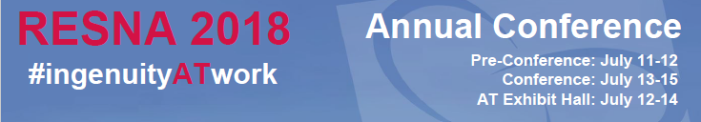

Sponsors, Exhibitors, and Advertisers
RESNA 2018 is fast approaching. We want to thank you for choosing to join us in Arlington this July. Below, you’ll find information about how to engage with the attendees of the conference. If you have questions, please reach out to conference@resna.org. If you have questions on-site, please stop by the RESNA for help.

DIGITAL REQUIREMENTS
High-resolution 300 dpi images are preferred (can be emailed to conference@resna.org). InDesign files are acceptable and must include fonts, links, etc. If sending application files, please submit hard copy with files.

PROGRAM DESCRIPTION
Exhibitors receive a 50-word description in the conference app, and a website link
- 50-word description: Click here to enter text.
- Website link: Click here to enter text.
- Facebook link: Click here to enter text.
- Twitter link: Click here to enter text.
- LinkedIn link: Click here to enter text.
- Google Plus/ YouTube link: Click here to enter text.

LOGO FOR CONFERENCE BAG
The conference bag given to each attendee. It will contain marketing literature, DC-themed items, and a helpful guide to the area.
- Black & White
- High resolution

MARKETING LITERATURE INSERT FOR CONFERENCE BAG
Please send this to the RESNA office:
RESNA
c/o Conference
1560 Wilson Blvd, Suite 850
Arlington, VA 22201
- 8.5” x 11”
- or 4.25” x 5.5”

HIGH RESOLUTION LOGO FOR SIGNAGE THROUGHOUT THE CONFERENCE
Please deliver these files to conference@resna.org. We will place this on the website and throughout the conference.
- Color
- High resolution

